AIM: Implementation of at least five different SQL nested sub queries in WHERE clause on each “Banking, University and database Project assigned to each student”, by running on WAMP/ LAMP /XAMPP /SQL server.

Schema:
faculty data - Staff_info(Title,firstName,middleName,lastName,DEPARTMENT,EMAIL_ID,PHONE_NO,ROOM_NO,Graduate (UG),Postgraduate (PG),Doctorate (Ph.D.),AREA OF SPECIALIZATION)
printer_issue_detail(Title,firstName,middleName,lastName,EMAIL_ID,ROOM_NO,Designation,Printer_model,Date_of_last_refil,Status,Priority)

Procedure
1. Running 5 different SQL nested sub queries in select clause on each “Banking, University and database Project assigned to each student”:

In University Database:
    - Find All Students Who Are Advised by an Instructor from a Specific Department:

SELECT s_ID
FROM advisor
WHERE i_ID IN (SELECT i_ID
FROM instructor
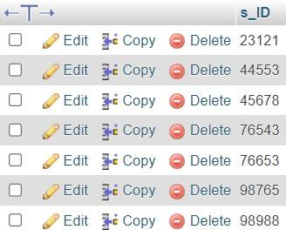
WHERE dept_name = 'Biology');
    - Find Students Who Have the Same Advisor as a Given Student (e.g., Student '23121'):
SELECT s_ID
FROM advisor
WHERE i_ID = (SELECT i_ID
FROM advisor
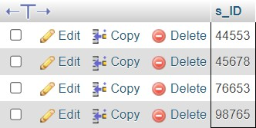
WHERE s_ID = '23121');

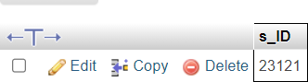

    - Find Students Advised by Instructors Who Advise More Than One Student:

SELECT s_ID
FROM advisor
WHERE i_ID = (SELECT i_ID
FROM advisor

WHERE s_ID = '23121');

    - Find Instructors Who Advise Students with a Specific Set of IDs (e.g., Students '23121' and '44553'):

SELECT i_ID
FROM advisor
WHERE i_ID IN
(SELECT i_ID
FROM advisor
WHERE s_ID IN ('23121', '44553')
GROUP BY i_ID
HAVING COUNT (DISTINCT s_ID) = 1);
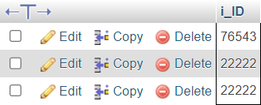

    - Find Students Advised by Instructors with the Highest Student Count:

1SELECT s_ID
FROM advisor
WHERE i_ID =

(SELECT i_ID
FROM advisor
GROUP BY i_ID
ORDER BY COUNT (s_ID) DESC
LIMIT 1);

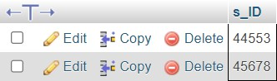
In Banking Database:
    - Fetching the account with the highest balance:

SELECT
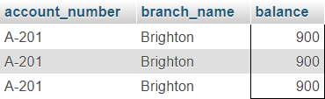
FROM account
WHERE balance = (SELECT MAX(balance) FROM account);

    - Selecting an account with the lowest balance in a specific branch:

SELECT
FROM account
WHERE balance
(SELECT MIN(balance)
FROM account
WHERE branch_name
'Downtown');

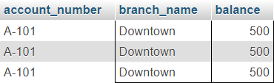
    - Finding an account whose balance matches the maximum balance across all accounts:

SELECT
FROM account
WHERE balance = (SELECT MAX(balance)
FROM account);

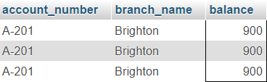

    - Fetching the account from the branch with the fewest accounts:

SELECT *
FROM account
WHERE branch_name = (SELECT branch_name
FROM account
GROUP BY branch_name
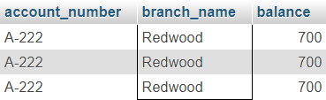
ORDER BY COUNT(*) ASC
LIMIT 1);

5) Selecting an account with a balance closest to the highest balance but not the highest:

SELECT
*
FROM account
WHERE balance
=
(SELECT MAX(balance)
FROM account
WHERE balance < (SELECT MAX(balance) FROM account));
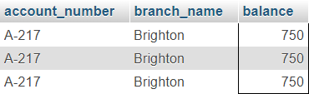

In Assigned Database:

    - Find faculty who have a specific printer model

SELECT firstName, lastName, EMAIL_ID
FROM faculty_data___staff_info
WHERE EMAIL_ID IN (
SELECT EMAIL_ID
FROM printer_issue_detail
WHERE Printer_model = 'Canon_6230dn'
);

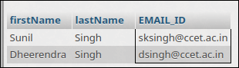

    - Find faculty who haven't had their printer refilled in over a year
SELECT firstName, lastName, EMAIL_ID
FROM faculty_data___staff_info
WHERE EMAIL_ID IN (
SELECT EMAIL_ID
FROM printer_issue_detail
WHERE DATEDIFF(CURDATE(), STR_TO_DATE(Date_of_last_refil, '%d-%m-%Y')) > 365
);
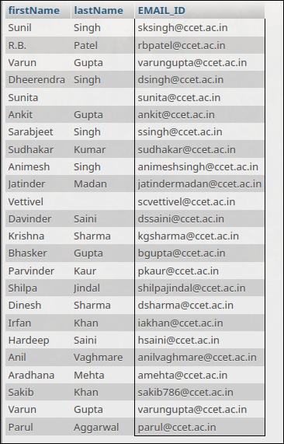

3) Find faculty from a specific department who have printers of certain models

SELECT firstName, lastName, DEPARTMENT, EMAIL_ID
FROM faculty_data___staff_info
WHERE DEPARTMENT = 'CSE'
AND EMAIL_ID IN (
SELECT EMAIL_ID
FROM printer_issue_detail
WHERE Printer_model IN ('Brother_7500D', 'Canon_6230')
);

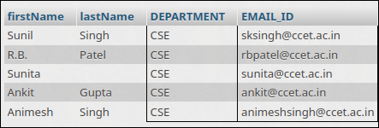

4) Find faculty from a specific department with priority status
SELECT firstName, lastName, DEPARTMENT, EMAIL_ID
FROM faculty_data___staff_info
WHERE DEPARTMENT = 'CSE'
AND EMAIL_ID IN (
SELECT EMAIL_ID
FROM printer_issue_detail
WHERE Priority IS NOT NULL
);

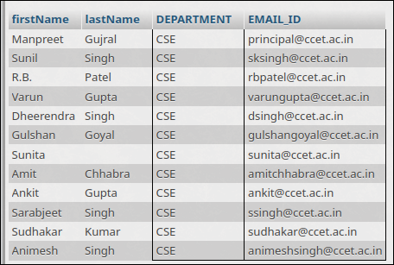

5. Find faculty who use the same printer model as another faculty

SELECT firstName, lastName, EMAIL_ID
FROM faculty_data___staff_info
WHERE EMAIL_ID IN (
SELECT EMAIL_ID
FROM printer_issue_detail
WHERE Printer_model IN (
SELECT Printer_model
FROM printer_issue_detail
WHERE EMAIL_ID = 'sksingh@ccet.ac.in'
)
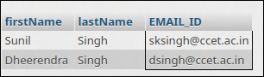
) LIMIT 0, 25;

